**Lab – 9: Customize group settings in Azure.**

**Objective:** The objective of this lab is –

* To customize group settings in Azure.

**Prerequisite:** EMS Enterprise Mobility + Security E5.

**Steps:**

1. Sign in to your Azure Portal, by using the link - **https://portal.azure.com/**. Enter your credentials and click Sign In.

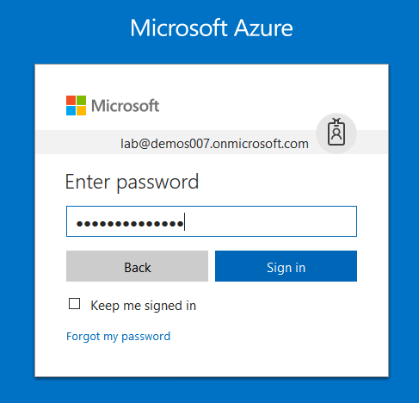

1. Microsoft Azure AD Dashboard will open.

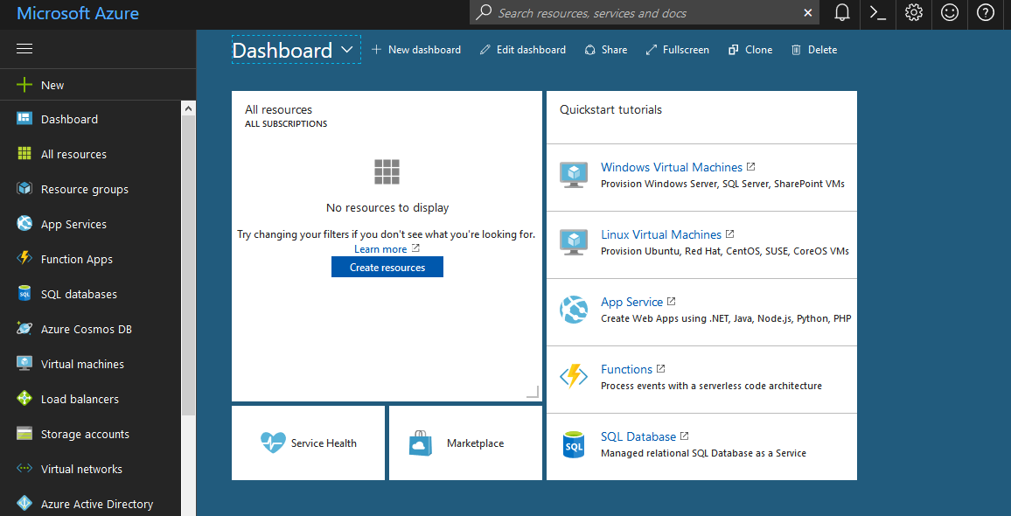

1. Now click **Azure Active Directory** from left-hand pane, and then select **Users and Groups** then select **Group Settings** in the **Manage** section.

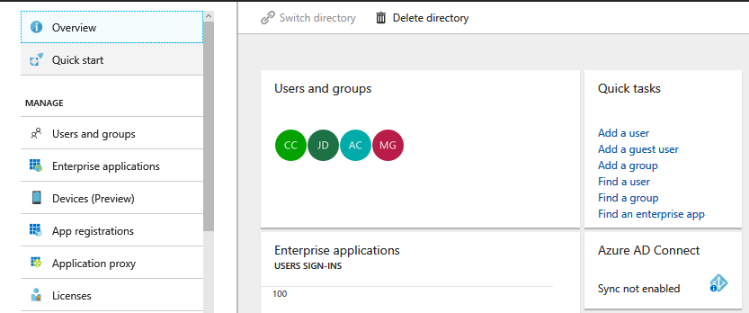

1. In this you will get **General** and **Expiration (preview)** settings, under Manage section.

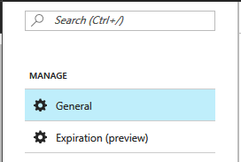

1. General settings page, will automatically open at the right-hand side, when you go to User Settings.

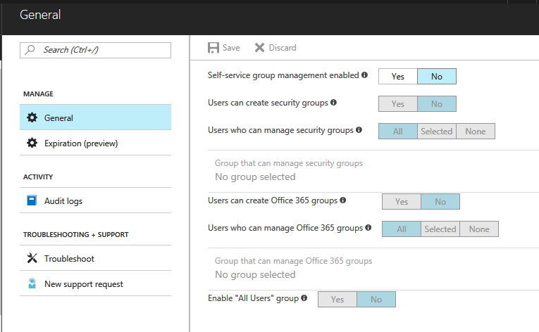

1. Here, you’ll get settings like – Self-service group management enabled, Users can create security groups, Users who can manage security groups, Users can create Office 365 groups, Users who can manage Office 365 groups and Enable “All Users” group.
2. If self-service group management is enabled, then you can enable self-service group management for users through the Access Panel. Like, here you can see all the configuration settings are disable except Self-service group management enabled. You can click **Yes** to enable it. After clicking Yes, you can see the other options will get enable to configure.

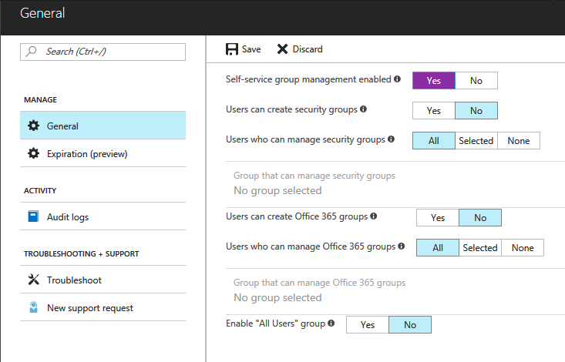

1. And, now you can configure other settings. Users can create security groups, enable users to create new security groups through the Access Panel. Click Yes, to enable this setting.

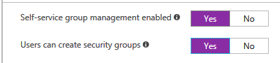

1. User who can manage security groups. Here, you will get three options – All, Selected and None. Select SOME to restrict security group management to only a limited group of users. For this click Selected, then click **Group that can manage security groups**.

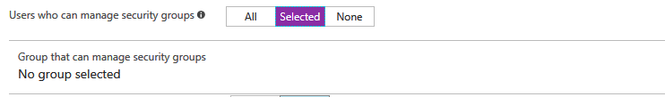

1. **Invite** box will open from where you can select a group that can manage security groups. Select a Group from the list or type name or email address in the search box to search. Then click **Select** button at the bottom of this page.

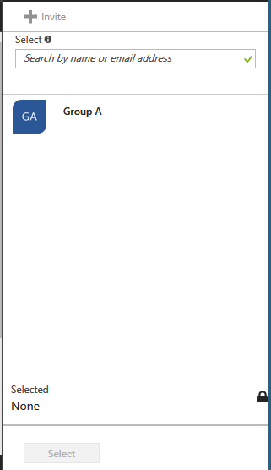

1. Then, Users can create Office 365 groups, choose yes or no according to your choice. Users who can manage Office 365 groups, you can also configure this according to the requirement of your enterprise. And, Enable “All Users” group, so select YES to enable the All Users group in the directory. So, in this way whatever changes you want to make for the group you can do using Azure.

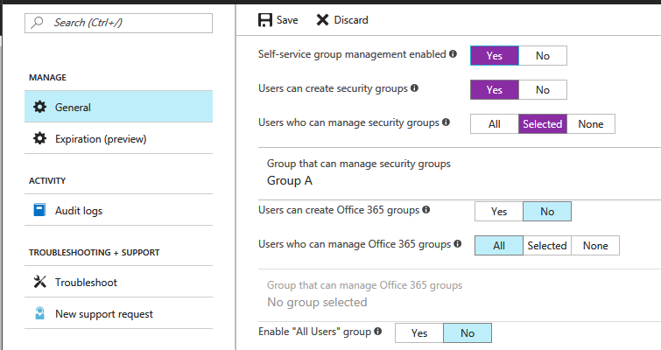

1. Then click **Save** from the top menu.



1. After, clicking Save, you will get the notification that **Successfully updated group settings**.

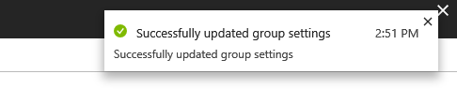

1. Now, click **Expiration (preview)** from the blade under Manage section.

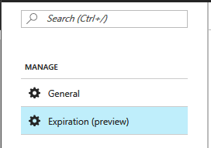

1. From this you can configure **Group Lifetime (in days**). You can select 180 days or 365 days or customize the days as per your choice from the drop-down menu.

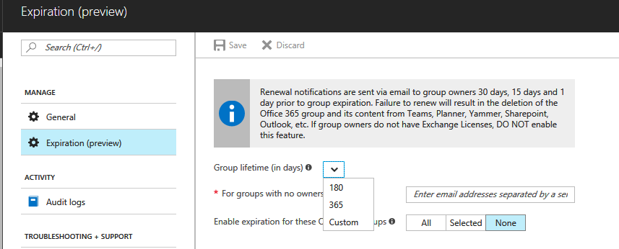

1. For groups with no owners. In the text field, enter list of email addresses separated by a semicolon ';'.
2. And, enable expiration for these Office 365 groups. So, select Office 365 groups if you want to enable expiration. Select All, if you want to enable expiration for all Office 365 groups. For selected groups click **Selected**, then Select Office 365 groups. Invite box will open, from where you can select Office 365 groups then click **Select**. Or leave it None, if you don’t need to enable this setting.

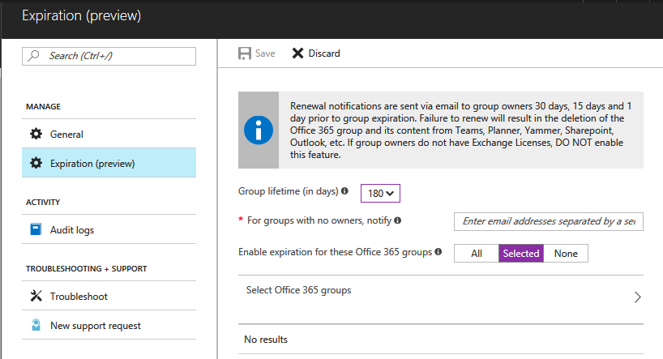

1. Then click Save, to save all the configuration settings.
2. So, in this way you can customize group settings in Azure.